ISSACK WAITHAKA
cs-sa07-24085

Introduction
- It examines and interprets log event data generated by various sources to monitor metrics and identify security incidents

Log analysis Basics
- Logs are stream of time-sequenced messages that record occurring events
- Each log contain relevant details such as timestamp, source etc.
- Logs are important because they help in system troubleshooting, cyber security incidents, Threat hunting and compliance.

Investigation Theory
- Timeline is a chronological representation of the logged events.
- Timestamps records when an event occurred, they are converted to UNIX.
- Super timeline/ consolidated timeline – provide a comprehensive view of events across different systems
- Data visualization help to convert raw data log into interactive and insightful visual representation through a user interface.

Questions
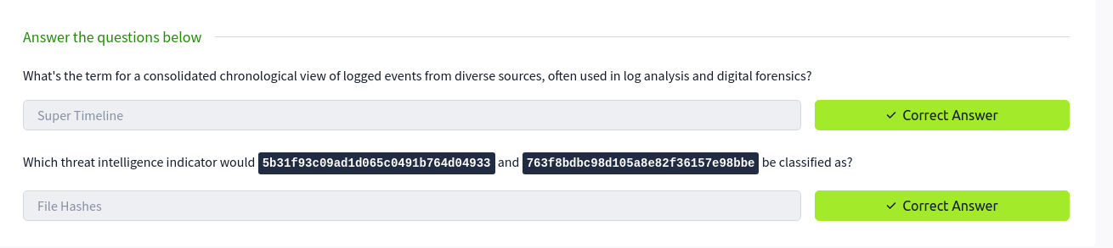

Detection Engineering
- Understanding where log files are located is very important
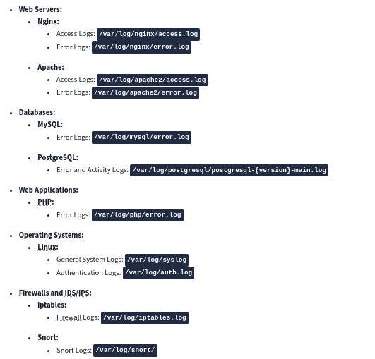
-
- Log detection engines are important because they can detect an abnormal behavior patterns and alert as potential security incidents.

Questions

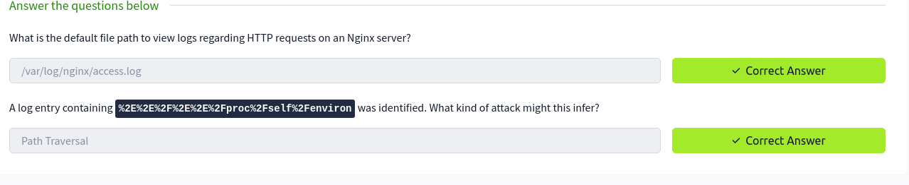

Automated vs. Manual Analysis
- Automated analysis involves using of tools I.e commercial. It allows processing and data analysis of logs
- Manual analysis involves examining data and artifacts without using automation tools

Questions
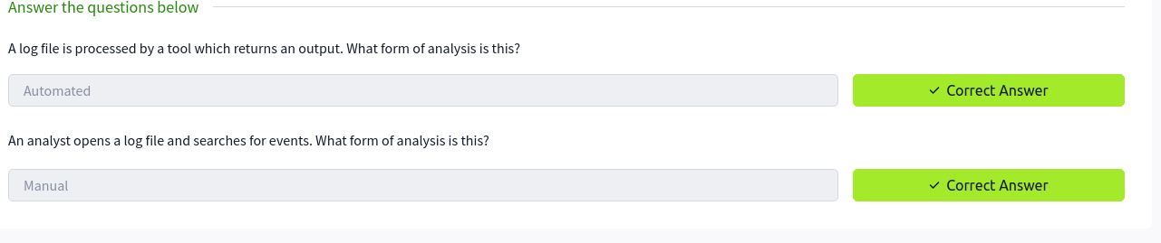

Log Analysis tools: Command Line
- Analyzing logs through the command line provides a quick and powerful way to gain insights into system activities.

Questions
1.

I used this command
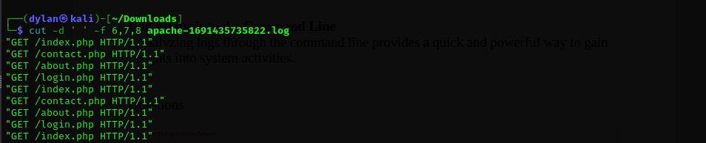
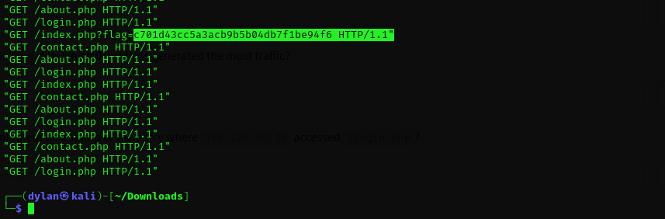
and got this
2.
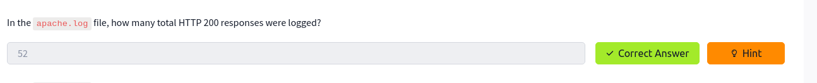
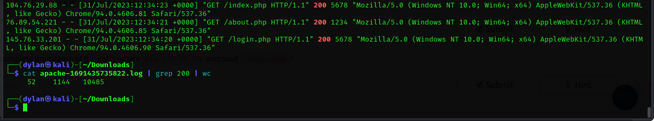
3.
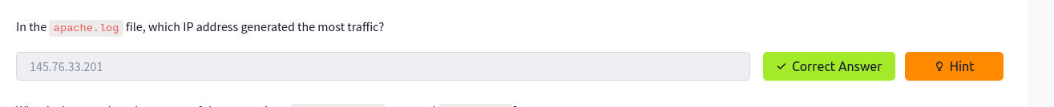
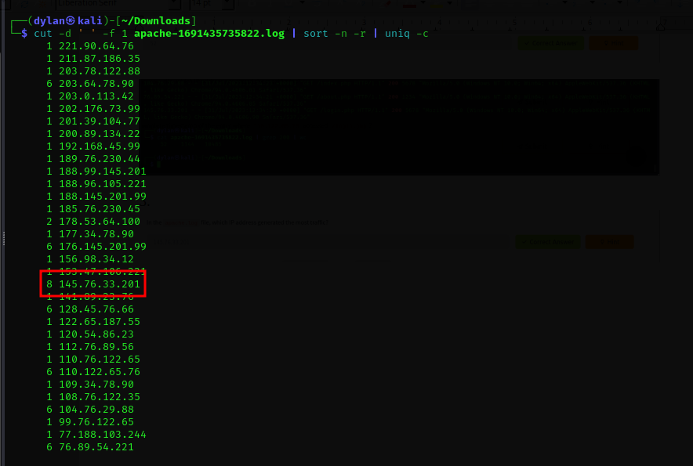

4.

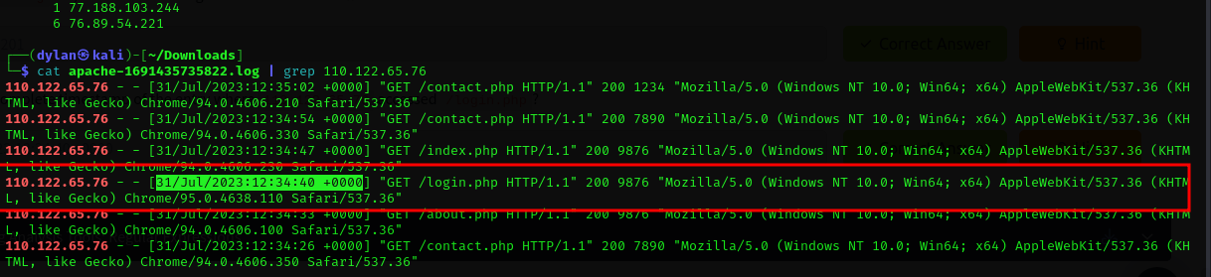

Log Analysis Tool: Regular Expressions
- Regex are invaluable way for searching, matching and manipulating text data.
- They are used to extract relevant information, filter data, identify pattern before forwarding them to the SIEM.

Questions
1.

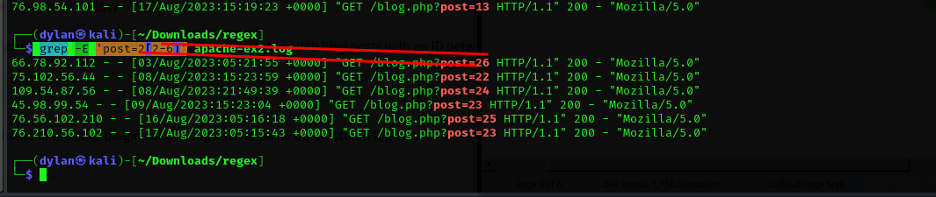
2.


Log Analysis Tools: Cyberchef
Questions
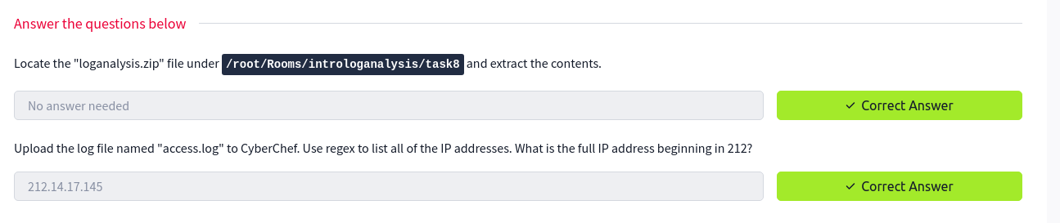
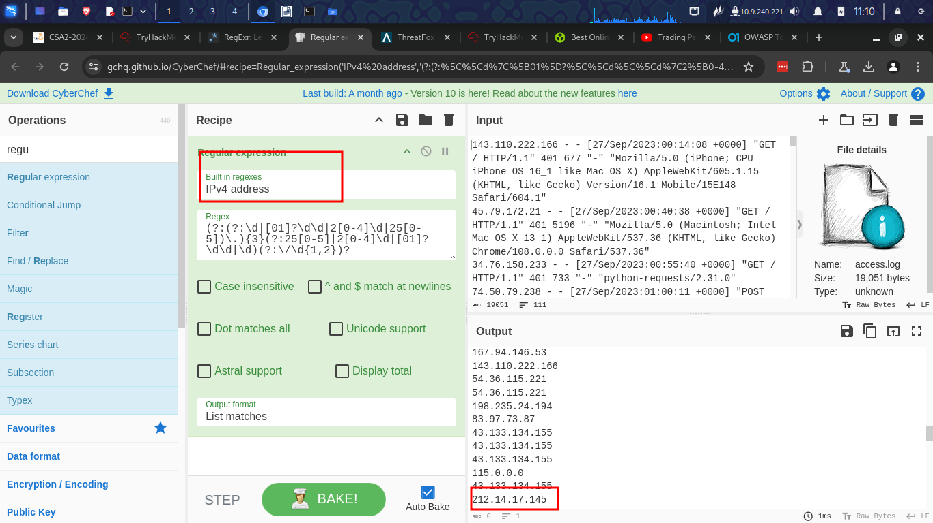
2.

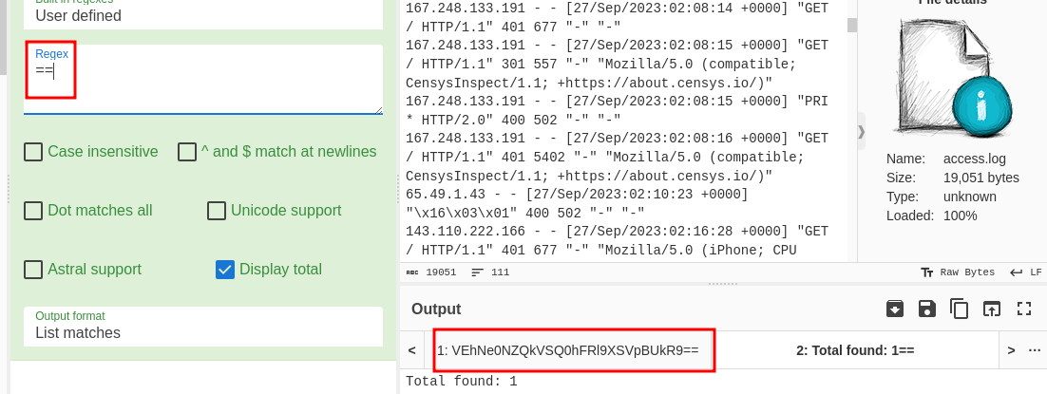
- base 64 is a multiple of and will most likely have ‘==’ at the end

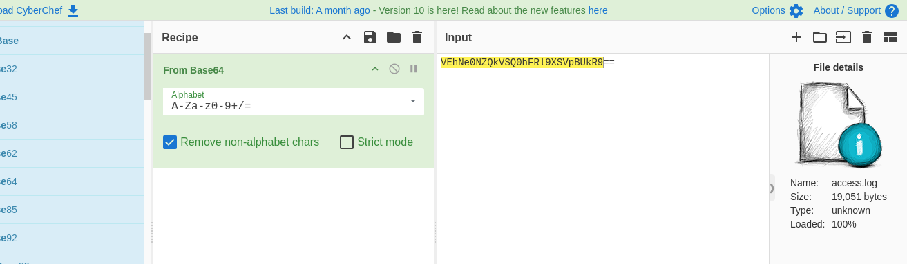
3.

I converted the file from base64. And got the following

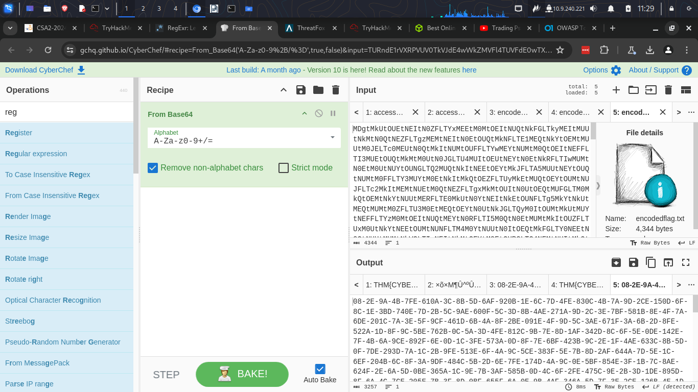

I then used regex to filter for mac address and I got the value

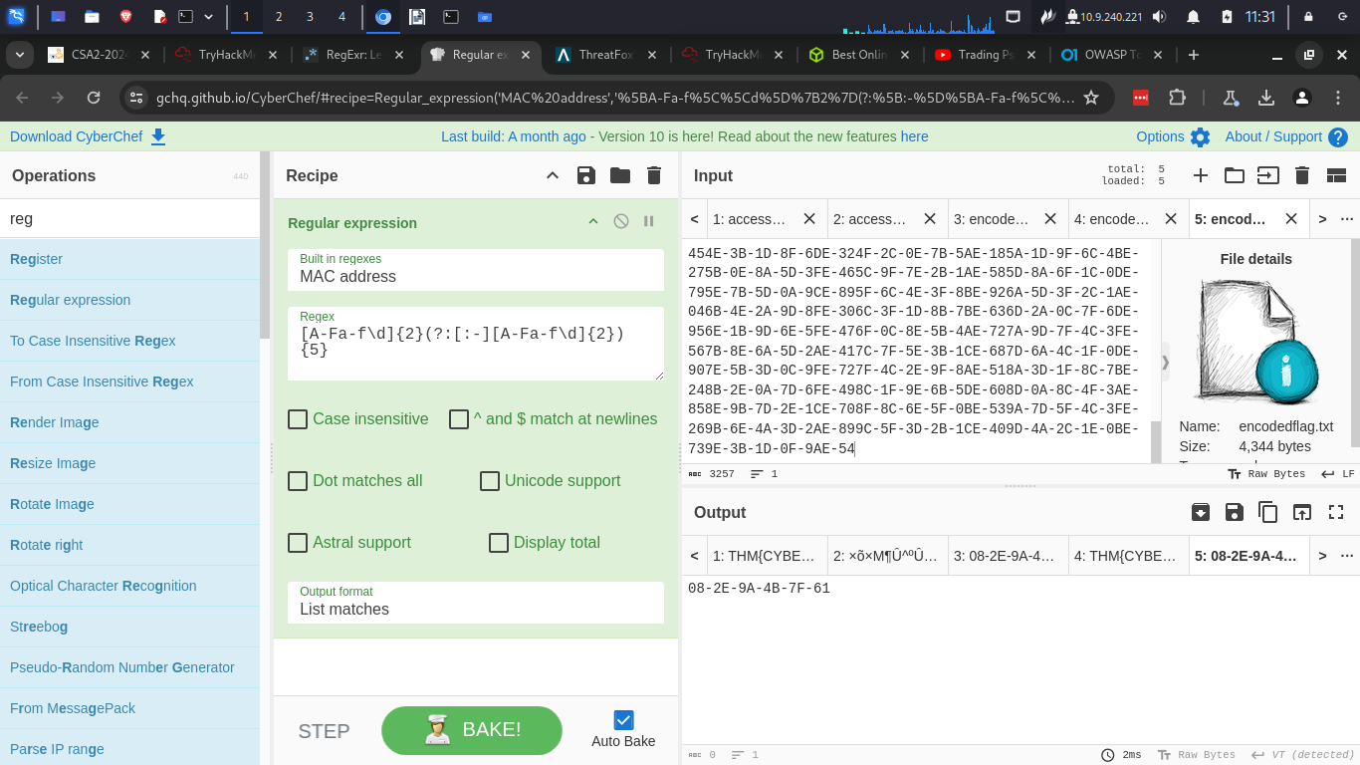

Log Analysis tools: Yara and Sigma
- Sigma is a an open-source tool that describes log events in a structured format.
- It can be used to find entries in log files.
- Yara is a formatted tool that identifies information based on binary and textual patterns

Questions
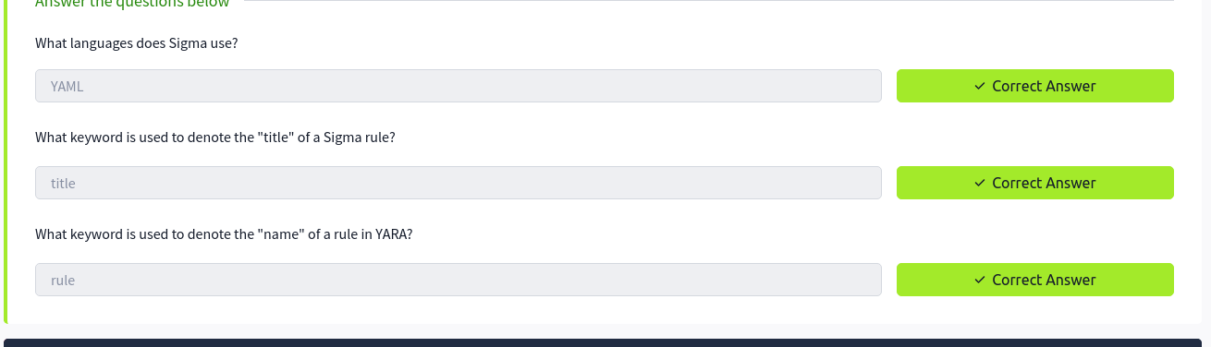

Conclusion

In this module I have learnt about logs and how they are important in cyber security.
I have learnt that logs are located in various places depending with your operating system. I have learnt how to analyze logs by using various tools. I now know that logs play a major role in security.

